1. **CSS Borders**

The CSS border properties allow you to specify the style, width, and color of an element's border.

**The border-style  property specifies the what kind of border to display.**

The following border properties are used to display border.

* dotted - Defines a dotted border
* dashed - Defines a dashed border
* solid - Defines a solid border
* double - Defines a double border
* groove - Defines a 3D grooved border. The effect depends on the border-color value
* ridge - Defines a 3D ridged border. The effect depends on the border-color value
* inset - Defines a 3D inset border. The effect depends on the border-color value
* outset - Defines a 3D outset border. The effect depends on the border-color value
* none - Defines no border
* hidden - Defines a hidden border
* Dotted top, solid right, double bottom and dashed left

border-style: dotted solid double dashed;

* Dotted top, solid right/left, double bottom

border-style: dotted solid double;

* Dotted top/bottom, solid right/left

border-style: dotted solid;

**The border-width property specifies the width of the four borders.**

* 25px top, 10px right, 4px bottom and 35px left

border: solid;

border-width: 25px 10px 4px 35px;

* 10px top, 5px right/left, 15px bottom

border: solid;

border-width: 10px 5px 15px;

* 20px top and bottom, 5px on the sides

border: solid;

border-width: 20px 5px;

**The border-Colour property specifies the Colour of the four borders.**

* red top, green right, blue bottom and yellow left

border:solid;

border-color: red green blue yellow;

* red top, green right/left, blue bottom

border: solid;

border-color: red green blue;

* red top and bottom, green on the sides

border: dottd;

border-color: red green;

**All border properties in one content**

border: solid green 5px;

**if we want specifying the border in particular side**

border-top: solid green 5px;

border-bottom: solid green 5px;

border-right: solid green 5px;

border-left: solid green 5px;

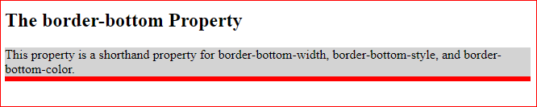

# CSS Rounded Borders

**1 All side bands with this**

p {  
  border: 2px solid red;  
  border-radius: 5px;  
}

**1 Individual side bands with this**

border-top-left-radius: 30px;

border-top-right-radius: 30px;

border-bottom-top-radius: 30px;

border-bottom-radius: 30px;

**Note:-**  Inline elements, such as a <span>, will completely ignore the width and height as well the top and bottom margin properties because, inline tag automatically manage the height and width according to content.